Position Budgets

Note on Position Dates tab
Kathy says that at some Campus Management customers when an employee got promoted from Accountant 2 to Accountant 1, that wasn’t a new position but just a new title. In other words, once you’re in a position 502001, you’re always in the position 502001. The dates allow you to keep the history of the titles associated with the position. For reporting, Empower shows the position title associated with the end date on the employee positions row.
Position Budget Initialization
Uses vw_position_budget_initialization_positions to get the positions that are active as of the Positions As of Date. Allows the user to enter a percent change for each position.
Positions have a fringe benefit percent and a fringe percent amount.
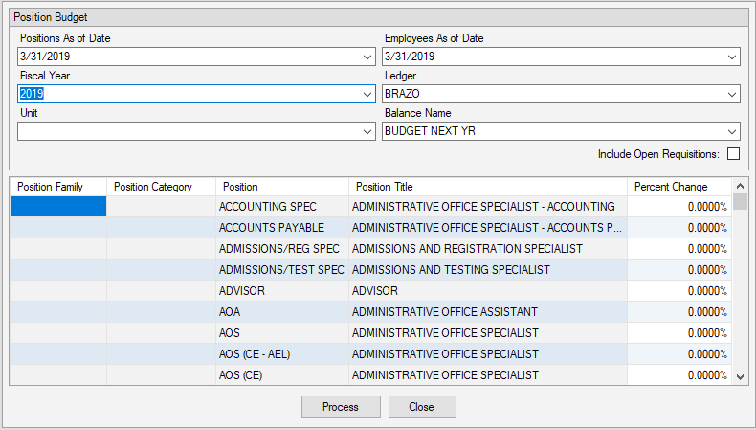
Uses position_budgets to get the position budget “items” for the specified fiscal year, ledger, unit, and balance name. Calls those “items to delete”.
Uses vw_position_budget_initialization_employees to get employees that are active and in the positions on the Employees As of Date. Also uses the Employees As of Date to get the rate for their base pay.

Uses vw_position_budget_initialization_requisitions to get position_requisitions where the expected_start_date is less than or equal to the Employees As of Date.

Deletes existing position_budgets.

For each employee in vw_position_budget_initialization_employees

- Gets the user-entered percent increase for the position and adds a new position budget item (which will get written into position_budgets).

Dim positionBudgetItem = positionBudget.Items.AddNew

With positionBudgetItem
.Position = item.Position
.Employee = item.Employee
.PostingAccount = item.EmployeePostingAccount
.AnnualWagesAmount = item.AnnualAmount * (decPercentChange + 100D) / 100D
.FringeBenefitAmount = item.FringeBenefitAmount
.FringeBenefitPercent = item.FringeBenefitPercent
.FTEPercent = item.FTEPercent
End With

- Does positionBudgetItem.Validate (but I can’t find that. After watching it in Debug, there code in PositionBudgetAllocationItem that ran as part of this and validated that the posting account was a valid Wages account.)

For each requisition in vw_position_budget_initialization_requisitions

- Gets the user-entered percent increase for the position and adds a new position budget item (which will get written into position_budgets).

Dim positionBudgetItem = positionBudget.Items.AddNew

With positionBudgetItem
.Position = item.Position
.PostingAccount = item.PostingAccount
.AnnualWagesAmount = item.MidpointSalaryAmount * (decPercentChange + 100D) / 100D
.FringeBenefitAmount = item.FringeBenefitAmount
.FringeBenefitPercent = item.FringeBenefitPercent
.FTEPercent = 100D
End With

Doesn’t use a spread rule but spreads the amount equally over 12 periods. I believe we could change this easily enough with a preference.

When someone’s base pay is allocated to multiple posting accounts, they show under both of those organizations in Position Budgets. Each organization has the amount that applies to it.

Will get the following error if someone’s base pay rate event has a blank posting account rather than a NULL posting account.

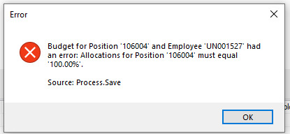

Position Budgets

Has a Create Position button on it. You can use it to create new position not associated with an employee (or even associated with an employee), and have it appear in Position Budgets. The position is created with the Pending checkbox checked.

